Town of Montrose
PUBLIC HEARING
1341 Diane Ave., Belleville WI 53508
Tuesday August 2, 2022, at 7:00 PM
Regular Board Meeting to follow

- Discussion and/or Recommendation on Vacation of 49.5 foot wide strip of land that is part of the SE and SW quarters of the SW quarter, Section 20, Town 5 North, Range 8 East, Town of Montrose, Dane County, Wisconsin.

Commencing at the South Quarter corner. Vacating approximately 786 feet of Feller Road north of Pioneer Cemetery.

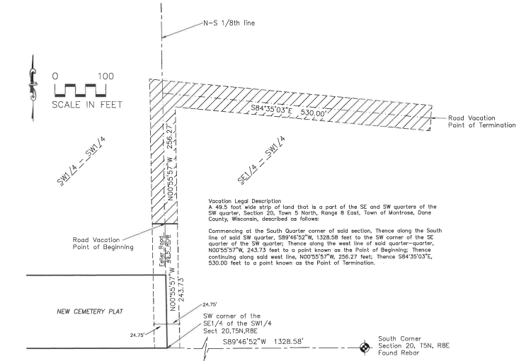

The TOWN OF MONTROSE IS IN COMPLIANCE WITH THE AMERICANS WITH DISABILITIES ACT. Efforts will be made to accommodate the needs of disabled individuals through appropriate aids and services upon reasonable notice. For additional information or to request this service, contact the Town of Montrose, 1341 Diane Avenue, Belleville WI 53508, (608)424-3848 by the Friday prior to meeting.

Posted: Montrose Town Hall, Paoli Park, www.townofmontrose.com; 27 July 2022

