Notice of Spring Primary and

Sample Ballots

April 5, 2022

Office of the Town of Montrose Clerk

To the voters of Town of Montrose:

Notice is hereby given of a spring primary election to be held in Town of Montrose on April 5, 2022, at which the officers named below shall be nominated. The names of the candidates for each office, whose nominations have been certified to or filed in this office, are given under the title of the office, each in its proper column, together with the questions submitted to a vote, for a referendum, if any, in the sample ballot below.
Information to Voters
Upon entering the polling place and before being permitted to vote, a voter shall:
- state their name and address
- show an acceptable form of photo identification*
- sign the poll book**

*If a voter does not have acceptable photo identification, the voter may obtain a free photo ID for voting from the Division of Motor Vehicles.

**If the voter is unable to sign the poll book due to disability, a poll worker may write the word “exempt.”

If a voter is not registered to vote, they may register to vote at the polling place serving their residence if the voter provides proof of residence.

Where ballots are distributed to voters, the initials of two inspectors must appear on the ballot.

Upon being permitted to vote, the voter shall enter a voting booth or go to a machine and cast their ballot. The vote should not be cast in any manner other than specified here. Sample ballots or other materials to assist the voter in marking their ballot may be taken into the booth and copied. The sample ballot shall not be shown to anyone so as to reveal how the ballot is marked.

A voter who is a parent or guardian may be accompanied by the voter's minor child or minor ward.

An election official may inform the voter of the proper manner for casting a vote but the official may not advise or indicate a particular voting choice.

Assistance for Voting
A voter may select an individual to assist in casting their vote if the voter declares to the presiding official that they are unable to read, have difficulty reading, writing, or understanding English, or that due to disability are unable to cast their ballot. The selected individual rendering assistance may not be the voter's employer or an agent of that employer or an officer or agent of a labor organization which represents the voter.

Where Paper Ballots are Used
The voter shall make a mark (X) in the square next to the name of the candidate of his or her choice for each office for which they intend to vote. To vote for a person whose name does not appear on the ballot, the voter shall write in the name of the person of their choice in the space provided for a write-in vote. On referendum questions, the voter shall make a mark (X) in the square next to "yes" if in favor of the question, or the voter shall make a mark (X) in the square next to "no" if opposed to the question.

Where Optical Scan Voting is Used
The voter shall fill in the oval or connect the arrow next to the name of the candidate of their choice for each office for which he or she intends to vote. To vote for a person whose name does not appear on the ballot, the voter shall write in the name of the person of their choice in the space provided for a write-in vote and fill in the oval or connect the arrow next to the write-in line. On referendum questions, the voter shall fill in the oval or connect the arrow next to "yes" if in favor of the question, or the voter shall fill in the oval or connect the arrow next to "no" if opposed to the question.

When using an electronic ballot marking device (“Automark,” “ExpressVote,” Clear Access or “ImageCast Evolution-ICE”) to mark an optical scan ballot, the voter shall touch the screen or use the tactile pad to select the name of the candidate of their choice for each office for which they intend to vote. To vote for a person whose name does not appear on the ballot, the voter shall type in the name of the person of their choice in the space provided for a write-in vote. On referendum questions, the voter shall touch the screen or use the tactile pad to select "yes" if in favor of the question, or the voter shall touch the screen or use the tactile pad to select "no" if opposed to the question.

Where Touch Screen Voting is Used
The voter shall touch the screen or use the tactile pad to select the name of the candidate of their choice for each office for which they intend to vote. To vote for a person whose name does not appear on the ballot, the voter shall type in the name of the person of their choice in the space provided for a write-in vote. On referendum questions, the voter shall touch the screen at "yes" if in favor of the question, or the voter shall touch the screen at "no" if opposed to the question.

Spoiled Ballots
If a voter spoils a paper or optical scan ballot, they shall return it to an election official who shall issue another ballot in its place, but not more than three ballots shall be issued to any one voter. If the ballot has not been initialed by two inspectors or is defective in any other way, the voter shall return it to the election official, who shall issue a proper ballot in its place.
The voter may spoil a touch screen ballot at the voting station before the ballot is cast.

After Voting the Ballot
After an official paper ballot is marked, it shall be folded so the inside marks do not show, but so the printed endorsements and inspectors' initials on the outside do show. The voter shall deposit the voted ballot in the ballot box or deliver the ballot to an inspector for deposit and shall leave the polling place promptly.
After an official optical scan ballot is marked, it may be inserted in the security sleeve, so the marks do not show. The voter shall insert the ballot in the voting device and discard the sleeve or deliver the ballot to an inspector for deposit. If a central count system is used, the voter shall insert the ballot in the ballot box and discard the sleeve or deliver the ballot to an inspector for deposit. The voter shall leave the polling place promptly.
After an official touch screen ballot is cast, the voter shall leave the polling place promptly.

The following are samples of the official ballots (based on school district).
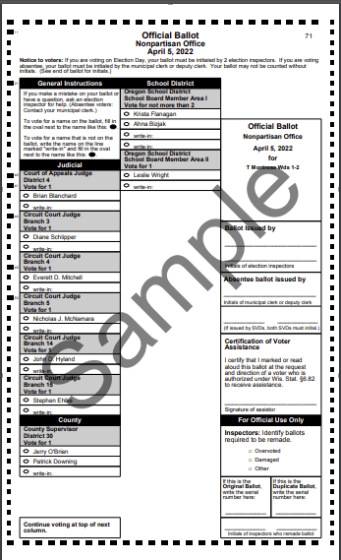

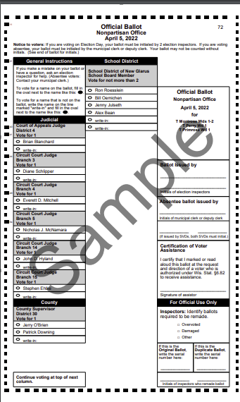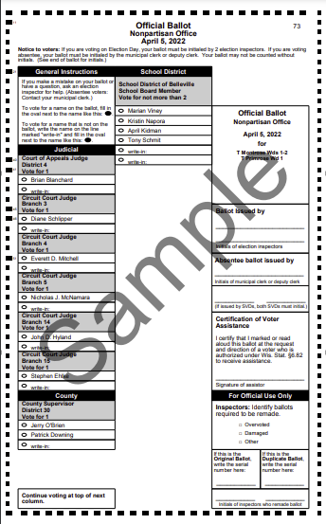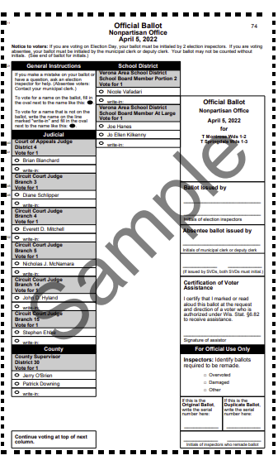
Jennifer Novinska, Town Clerk

